**Assignment 4.5**

library(RcmdrPlugin.IPSUR)

data(RcmdrTestDrive)

Perform the below operations:

1. Compute the measures of central tendency for salary and reduction which variable has highest center?

library(RcmdrPlugin.IPSUR)

data(RcmdrTestDrive)

#Perform the below operations:

View(RcmdrTestDrive)

#1. Compute the measures of central tendency for salary and reduction

#which variable has highest center?

#first find the measures of central tendency for salary and reduction

#for salary

library(RcmdrPlugin.IPSUR)

x<- c(mean(RcmdrTestDrive$salary),median(RcmdrTestDrive$salary))

x

> x

[1] 724.5164 710.1500

#for reduction

y<- c(median(RcmdrTestDrive$reduction),mean(RcmdrTestDrive$reduction))

y

> y

[1] 139.500 223.631

library(psych)

kurtosi(RcmdrTestDrive$salary)

kurtosi(RcmdrTestDrive$reduction)

> kurtosi(RcmdrTestDrive$salary)

[1] 0.2006576

> kurtosi(RcmdrTestDrive$reduction)

[1] 10.01655

x<-RcmdrTestDrive$salary

h<- hist(x,breaks = 10,col = "red",xlab = "salary",main= "histogram of salary with normal curve")

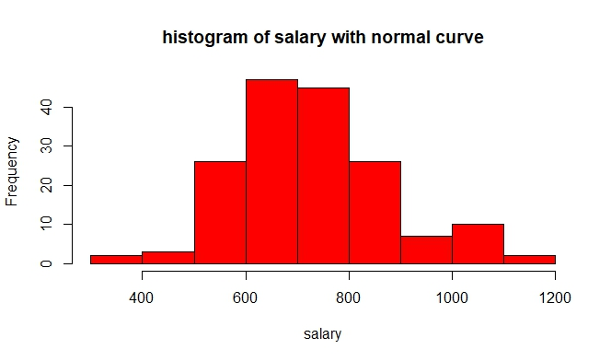

y<-RcmdrTestDrive$reduction

h<- hist(y,breaks = 10,col = "blue",xlab = "reduction",main= "histogram of reduction with normal curve")

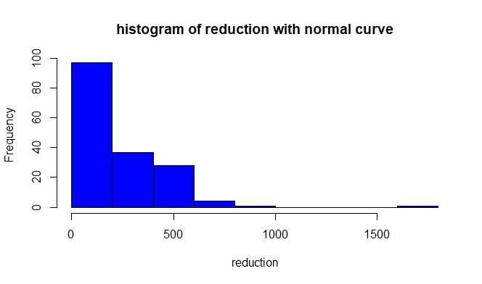

2. Which measure of center is more appropriate for before and after?

#by boxplot we can check for median where it lies

boxplot(RcmdrTestDrive$before,horizontal = T,col = "red",xlab="before",ylab="Boxplot")

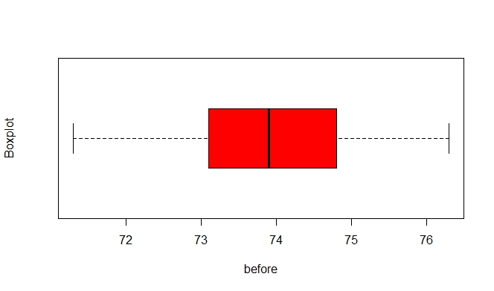

#normal distributed

boxplot(RcmdrTestDrive$after,horizontal = T,col = "red",xlab="after",ylab="Boxplot")

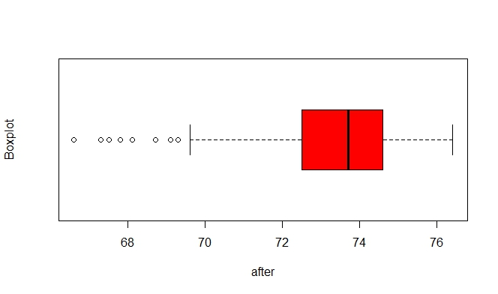

#left skewed as the data is assymetrical distributed

#if we check the skewness of variables

skew (RcmdrTestDrive$before)

skew (RcmdrTestDrive$after)

> skew (RcmdrTestDrive$before)

[1] -0.03510369

> skew (RcmdrTestDrive$after)

[1] -1.164056